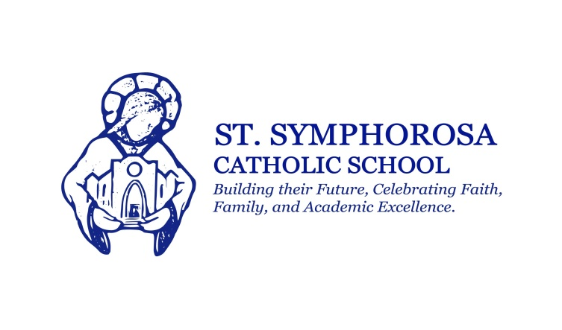
Hello families!

Help your child's class win an ice cream party! Your child's class can enjoy this treat by sharing our new school video on Facebook! It's easy!

Step 1

Click HERE to view our video page

Step 2

Just below our video, click the box marked "share". Select "Facebook" to post the video on your Facebook page. Encourage your friends to share!

Step 3

Simply screenshot your results and email it to rbanden@stsymphorosaschool.org by Tuesday, May 3rd.

The parent with the most shares will win an ice cream party for their child's class!

Thank you for helping us spread the word about our amazing school!

Richard Banden
Marketing Director

