**St. Symphorosa School Rock stars**

**Welcome our Protectors to Honor and Bless them on the Feast of St. Michael the Archangel**

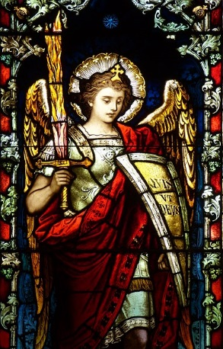

**Tuesday, September 29th between 10:15am-10:45am**



Plan to drive around our school community in your First responder vehicles for a blessing and for our students to show you our **gratitude**. Students will be lining the streets around the full city block on 61st and 62nd and Austin and Mason.